Dynamic Testing

What is Dynamic Testing
# Source: AI Source: Provided by: [Data Path: Persons Table -> ID Column: 1, Name_En Column: Motasem Essam] -> From: [ChatGPT] on [8/23/2025]
Dynamic Testing is a type of software testing that requires the program to be executed (run) in order to check its behavior, functionality, and performance.
- It is called “dynamic” because the software is running and its outputs are observed.
- Goal: to confirm the software works as expected when it is executed.

Examples of Dynamic Testing
# Source: AI Source: Provided by: [Data Path: Persons Table -> ID Column: 1, Name_En Column: Motasem Essam] -> From: [ChatGPT] on [8/23/2025]
- Executing a login function to see if correct/incorrect credentials are handled properly.
- Running test cases on a shopping cart to verify price calculation.
- Performing load testing on a website to see how it behaves under high traffic.

Levels of Dynamic Testing
# Source: AI Source: Provided by: [Data Path: Persons Table -> ID Column: 1, Name_En Column: Motasem Essam] -> From: [ChatGPT] on [8/23/2025]
Dynamic testing happens at different test levels:
- Unit/Component Testing – Testing small modules or functions.
- Integration Testing – Testing interactions between modules or systems.
- System Testing – Testing the complete system against requirements.
- Acceptance Testing – Testing with real users/business needs in mind.

Dynamic Testing Techniques
# Source: AI Source: Provided by: [Data Path: Persons Table -> ID Column: 1, Name_En Column: Motasem Essam] -> From: [ChatGPT] on [8/23/2025]
- Black-box techniques → e.g., Equivalence Partitioning, Boundary Value Analysis, Decision Tables, State Transition Testing, Use Case Testing.
- White-box techniques → e.g., Statement Coverage, Decision Coverage, Path Testing.

Difference from Static Testing
# Source: AI Source: Provided by: [Data Path: Persons Table -> ID Column: 1, Name_En Column: Motasem Essam] -> From: [ChatGPT] on [8/23/2025]
- Static Testing → No execution, just reviewing artifacts (requirements, design, code).
- Dynamic Testing → Execution is required; checks the actual running behavior.

✅ In short:
Dynamic Testing = Running the software + checking actual outputs vs. expected results.

Real-world analogy

🏧 Example: ATM Machine

🔹 Static Testing (no execution)
# Source: AI Source: Provided by: [Data Path: Persons Table -> ID Column: 1, Name_En Column: Motasem Essam] -> From: [ChatGPT] on [8/23/2025]
- Reviewing the ATM design document to check if it mentions:
  - A slot for the card
  - A keypad for PIN entry
  - A cash dispenser
- Checking the source code (without running it) to verify that PIN validation logic exists.
- Doing a walkthrough or review of the requirement: “ATM should lock after 3 wrong PIN attempts.”
👉 Here, nothing is executed. We only inspect documents/code.

🔹 Dynamic Testing (with execution)
# Source: AI Source: Provided by: [Data Path: Persons Table -> ID Column: 1, Name_En Column: Motasem Essam] -> From: [ChatGPT] on [8/23/2025]
- Actually inserting the card into the ATM and entering:
  - Correct PIN → should allow access
  - Wrong PIN 3 times → should lock the account
- Checking whether money is dispensed correctly after withdrawal.
- Testing with an expired card → should reject the transaction.
👉 Here, the ATM is running, and we are observing real outputs.

⚖️ Quick Difference Recap
# Source: AI Source: Provided by: [Data Path: Persons Table -> ID Column: 1, Name_En Column: Motasem Essam] -> From: [ChatGPT] on [8/23/2025]
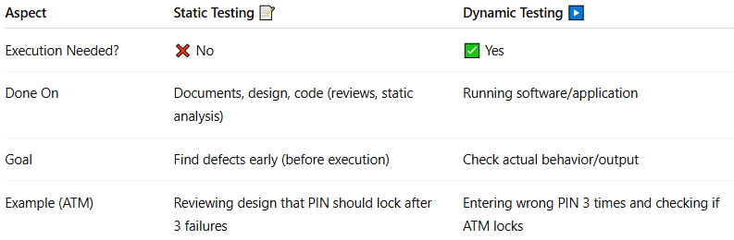
Aspect | Static Testing 📝 | Dynamic Testing ▶️
Execution Needed? | ❌ No | ✅ Yes
Done On | Documents, design, code (reviews, static analysis) | Running software/application
Goal | Find defects early (before execution) | Check actual behavior/output
Example (ATM) | Reviewing design that PIN should lock after 3 failures | Entering wrong PIN 3 times and checking if ATM locks

✅ Easy way to remember:
- Static = Stop, don’t run, just check
- Dynamic = Do, run it, and see

